Spring JDBC - Assignment
Assignment 1: Student Management System using Spring JDBC and MySQL
Objective
Develop a Spring Boot application using Spring JDBC and MySQL to manage student records.
Requirements
Database Setup
- Create a MySQL database named studentdb.
- Create a table named students with the following columns:
  - student_id (Primary Key)
  - student_name
  - email
  - course
  - marks
SQL Tasks
- Create the table using schema.sql.
- Insert at least 10 student records using data.sql.
Application Development
- Create a Spring Boot project with:
  - Spring JDBC
  - MySQL Driver
  - Spring Boot Starter
- Create the following classes:
  - Student.java
  - StudentRepository.java
  - StudentService.java
  - StudentRowMapper.java
- Use JdbcTemplate to implement:
  - Add Student
  - Update Student Details
  - Delete Student
  - Find Student by ID
  - Display All Students
- Implement a custom RowMapper to convert database records into Student objects.
Expected Output
- Display all students in the console.
- Search a student by ID.
- Update a student's marks.
- Delete a student record.
Deliverables
- Complete Source Code
- schema.sql
- data.sql
- Screenshot of Database Table
- Screenshot of Application Output
Solution:
Structure
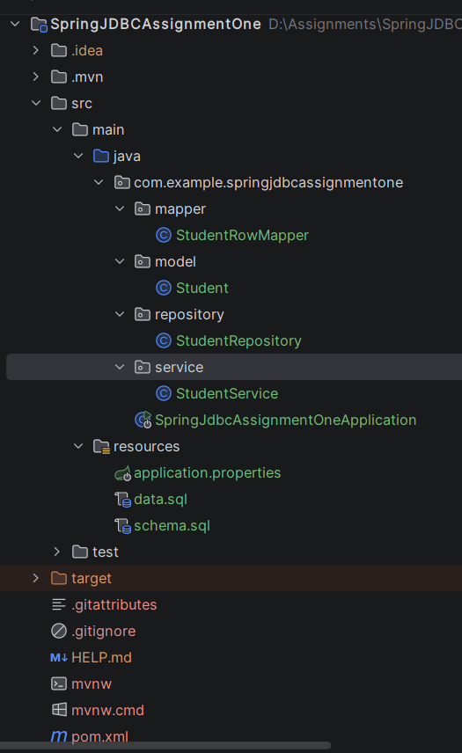
pom.xml
<?xml version="1.0" encoding="UTF-8"?>
<project xmlns="http://maven.apache.org/POM/4.0.0" xmlns:xsi="http://www.w3.org/2001/XMLSchema-instance"
xsi:schemaLocation="http://maven.apache.org/POM/4.0.0 https://maven.apache.org/xsd/maven-4.0.0.xsd">
<modelVersion>4.0.0</modelVersion>
<parent>
<groupId>org.springframework.boot</groupId>
<artifactId>spring-boot-starter-parent</artifactId>
<version>4.1.0</version>
<relativePath/> <!-- lookup parent from repository -->
</parent>
<groupId>org.example</groupId>
<artifactId>SpringJDBCAssignmentOne</artifactId>
<version>0.0.1-SNAPSHOT</version>
<name>SpringJDBCAssignmentOne</name>
<description>SpringJDBCAssignmentOne</description>
<url/>
<licenses>
<license/>
</licenses>
<developers>
<developer/>
</developers>
<scm>
<connection/>
<developerConnection/>
<tag/>
<url/>
</scm>
<properties>
<java.version>21</java.version>
</properties>
<dependencies>
<dependency>
<groupId>org.springframework.boot</groupId>
<artifactId>spring-boot-starter-data-jdbc</artifactId>
</dependency>
<dependency>
<groupId>com.mysql</groupId>
<artifactId>mysql-connector-j</artifactId>
<scope>runtime</scope>
</dependency>
<dependency>
<groupId>org.springframework.boot</groupId>
<artifactId>spring-boot-starter-data-jdbc-test</artifactId>
<scope>test</scope>
</dependency>
</dependencies>
<build>
<plugins>
<plugin>
<groupId>org.springframework.boot</groupId>
<artifactId>spring-boot-maven-plugin</artifactId>
</plugin>
</plugins>
</build>
</project>

resources/application.properties
spring.application.name=SpringJDBCAssignmentOne
spring.datasource.url=jdbc:mysql://localhost:3306/studentdb?useSSL=false&serverTimezone=UTC&allowPublicKeyRetrieval=true
spring.datasource.username=root
spring.datasource.password=root@123
spring.datasource.driver-class-name=com.mysql.cj.jdbc.Driver
spring.sql.init.mode=always
spring.sql.init.schema-locations=classpath:schema.sql
spring.sql.init.data-locations=classpath:data.sql

resources/schema.sql
USE studentdb;
CREATE TABLE IF NOT EXISTS students (
student_id INT AUTO_INCREMENT PRIMARY KEY,
student_name VARCHAR(100) NOT NULL,
email VARCHAR(100) UNIQUE NOT NULL,
course VARCHAR(50) NOT NULL,
marks INT NOT NULL
);

resources/data.sql
INSERT INTO students (student_name, email, course, marks) VALUES
('Aarav Sharma', 'aarav.s@example.com', 'Computer Science', 88),
('Diya Patel', 'diya.p@example.com', 'Information Technology', 92),
('Rohan Verma', 'rohan.v@example.com', 'Electronics', 79),
('Ananya Sen', 'ananya.s@example.com', 'Computer Science', 95),
('Vikram Singh', 'vikram.s@example.com', 'Mechanical', 71),
('Priya Nair', 'priya.n@example.com', 'Civil', 84),
('Karthik Raja', 'karthik.r@example.com', 'Information Technology', 90),
('Sneha Reddy', 'sneha.r@example.com', 'Computer Science', 86),
('Rahul Das', 'rahul.d@example.com', 'Electrical', 75),
('Meera Joshi', 'meera.j@example.com', 'Electronics', 89);

model.Student.java
package com.example.springjdbcassignmentone.model;
public class Student {
private int studentId;
private String studentName;
private String email;
private String course;
private int marks;
public Student() {}
public Student(String studentName, String email, String course, int marks) {
this.studentName = studentName;
this.email = email;
this.course = course;
this.marks = marks;
}
public Student(int studentId, String studentName, String email, String course, int marks) {
this.studentId = studentId;
this.studentName = studentName;
this.email = email;
this.course = course;
this.marks = marks;
}
public int getStudentId() { return studentId; }
public void setStudentId(int studentId) { this.studentId = studentId; }
public String getStudentName() { return studentName; }
public void setStudentName(String studentName) { this.studentName = studentName; }
public String getEmail() { return email; }
public void setEmail(String email) { this.email = email; }
public String getCourse() { return course; }
public void setCourse(String course) { this.course = course; }
public int getMarks() { return marks; }
public void setMarks(int marks) { this.marks = marks; }
@Override
public String toString() {
return String.format("ID: %-3d | Name: %-15s | Email: %-22s | Course: %-22s | Marks: %d",
studentId, studentName, email, course, marks);
}
}

repository/StudetRepository.java
package com.example.springjdbcassignmentone.repository;
import com.example.springjdbcassignmentone.mapper.StudentRowMapper;
import com.example.springjdbcassignmentone.model.Student;
import org.springframework.beans.factory.annotation.Autowired;
import org.springframework.jdbc.core.JdbcTemplate;
import org.springframework.stereotype.Repository;
import java.util.List;
@Repository
public class StudentRepository {
@Autowired
private JdbcTemplate jdbcTemplate;
public int save(Student student) {
String sql = "INSERT INTO students (student_name, email, course, marks) VALUES (?, ?, ?, ?)";
return jdbcTemplate.update(sql, student.getStudentName(), student.getEmail(), student.getCourse(), student.getMarks());
}
public int updateMarks(int id, int marks) {
String sql = "UPDATE students SET marks = ? WHERE student_id = ?";
return jdbcTemplate.update(sql, marks, id);
}
public int deleteById(int id) {
String sql = "DELETE FROM students WHERE student_id = ?";
return jdbcTemplate.update(sql, id);
}
public Student findById(int id) {
String sql = "SELECT * FROM students WHERE student_id = ?";
return jdbcTemplate.queryForObject(sql, new StudentRowMapper(), id);
}
public List<Student> findAll() {
String sql = "SELECT * FROM students";
return jdbcTemplate.query(sql, new StudentRowMapper());
}
}

service/StudentRepository.java
package com.example.springjdbcassignmentone.service;
import com.example.springjdbcassignmentone.model.Student;
import com.example.springjdbcassignmentone.repository.StudentRepository;
import org.springframework.beans.factory.annotation.Autowired;
import org.springframework.stereotype.Service;
import java.util.List;
@Service
public class StudentService {
@Autowired
private StudentRepository studentRepository;
public void addStudent(Student student) {
studentRepository.save(student);
}
public void updateStudentMarks(int id, int marks) {
studentRepository.updateMarks(id, marks);
}
public void deleteStudent(int id) {
studentRepository.deleteById(id);
}
public Student getStudentById(int id) {
return studentRepository.findById(id);
}
public List<Student> getAllStudents() {
return studentRepository.findAll();
}
}

mapper/RowMapper.java
package com.example.springjdbcassignmentone.mapper;
import com.example.springjdbcassignmentone.model.Student;
import org.springframework.jdbc.core.RowMapper;
import java.sql.ResultSet;
import java.sql.SQLException;
public class StudentRowMapper implements RowMapper<Student> {
@Override
public Student mapRow(ResultSet rs, int rowNum) throws SQLException {
Student student = new Student();
student.setStudentId(rs.getInt("student_id"));
student.setStudentName(rs.getString("student_name"));
student.setEmail(rs.getString("email"));
student.setCourse(rs.getString("course"));
student.setMarks(rs.getInt("marks"));
return student;
}
}
SpringJdbcAssignmentOneApplication.java
package com.example.springjdbcassignmentone;
import com.example.springjdbcassignmentone.model.Student;
import com.example.springjdbcassignmentone.service.StudentService;
import org.springframework.boot.CommandLineRunner;
import org.springframework.boot.SpringApplication;
import org.springframework.boot.autoconfigure.SpringBootApplication;
import org.springframework.context.annotation.Bean;
@SpringBootApplication
public class SpringJdbcAssignmentOneApplication {
public static void main(String[] args) {
SpringApplication.run(SpringJdbcAssignmentOneApplication.class, args);
}
@Bean
public CommandLineRunner run(StudentService service) {
return args -> {
System.out.println("\n================ ALL INITIAL STUDENTS ================");
service.getAllStudents().forEach(System.out::println);
System.out.println("\n================ SEARCH STUDENT BY ID (3) ================");
Student student = service.getStudentById(3);
System.out.println(student);
System.out.println("\n================ UPDATE MARKS FOR ID 3 (New Marks: 91) ================");
service.updateStudentMarks(3, 91);
System.out.println(service.getStudentById(3));
System.out.println("\n================ DELETE STUDENT ID 5 ================");
service.deleteStudent(5);
System.out.println("Student with ID 5 deleted successfully.");
System.out.println("\n================ ADD NEW STUDENT ================");
Student stud=new Student("Kavya Sundar", "kavya.s@gmail.com", "Cybersecurity", 94);
service.addStudent(stud);
System.out.println(stud);
System.out.println("New Student added successfully");
System.out.println("\n================ UPDATED ALL STUDENTS LIST ================");
service.getAllStudents().forEach(System.out::println);
};
}
}

Output:
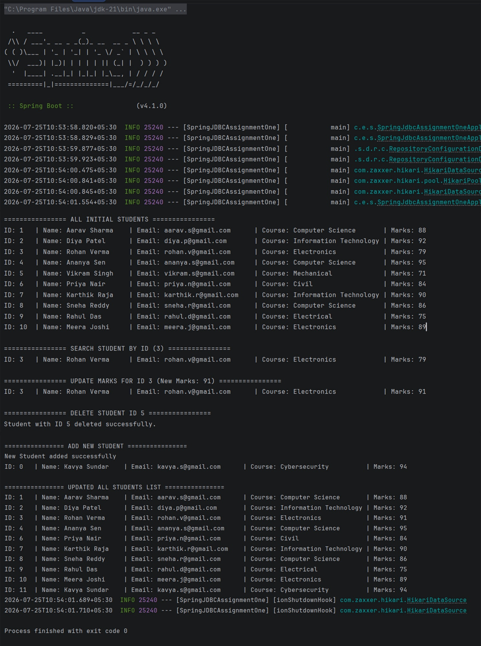
Database Table:
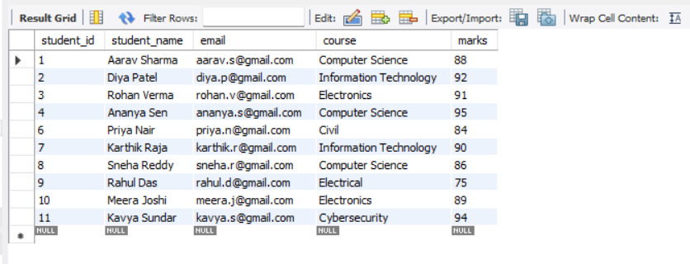

Assignment 2: Employee Payroll Management System using Spring JDBC and MySQL
Objective
Create a payroll management application using Spring JDBC and MySQL.
Requirements
Database Setup
- Create a MySQL database named payrolldb.
- Create an employees table with:
  - emp_id (Primary Key)
  - emp_name
  - department
  - designation
  - salary
SQL Tasks
- Create table using schema.sql.
- Insert at least 8 employee records using data.sql.
Application Development
- Create:
  - Employee.java
  - EmployeeRepository.java
  - EmployeeService.java
  - EmployeeRowMapper.java
- Implement the following operations using JdbcTemplate:
  - Add Employee
  - View All Employees
  - Search Employee by ID
  - Update Employee Salary
  - Delete Employee
- Display all employee details in the console.
Additional Requirement
Create a method to display employees whose salary is greater than ₹50,000.
Deliverables
- Complete Spring JDBC Project
- schema.sql
- data.sql
- MySQL Database Screenshot
- Console Output Screenshot
- Documentation explaining the use of:
  - JdbcTemplate
  - RowMapper
  - Repository Layer
  - Service Layer

Solution:
Structure
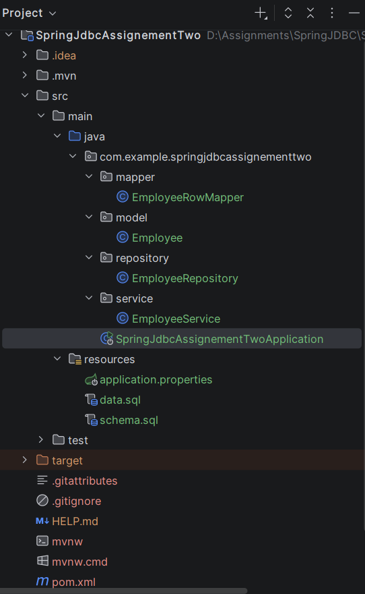

pom.xml
<?xml version="1.0" encoding="UTF-8"?>
<project xmlns="http://maven.apache.org/POM/4.0.0" xmlns:xsi="http://www.w3.org/2001/XMLSchema-instance"
xsi:schemaLocation="http://maven.apache.org/POM/4.0.0 https://maven.apache.org/xsd/maven-4.0.0.xsd">
<modelVersion>4.0.0</modelVersion>
<parent>
<groupId>org.springframework.boot</groupId>
<artifactId>spring-boot-starter-parent</artifactId>
<version>4.1.0</version>
<relativePath/> <!-- lookup parent from repository -->
</parent>
<groupId>com.example</groupId>
<artifactId>SpringJdbcAssignementTwo</artifactId>
<version>0.0.1-SNAPSHOT</version>
<name>SpringJdbcAssignementTwo</name>
<description>SpringJdbcAssignementTwo</description>
<url/>
<licenses>
<license/>
</licenses>
<developers>
<developer/>
</developers>
<scm>
<connection/>
<developerConnection/>
<tag/>
<url/>
</scm>
<properties>
<java.version>21</java.version>
</properties>
<dependencies>
<dependency>
<groupId>org.springframework.boot</groupId>
<artifactId>spring-boot-starter-data-jdbc</artifactId>
</dependency>
<dependency>
<groupId>com.mysql</groupId>
<artifactId>mysql-connector-j</artifactId>
<scope>runtime</scope>
</dependency>
<dependency>
<groupId>org.springframework.boot</groupId>
<artifactId>spring-boot-starter-data-jdbc-test</artifactId>
<scope>test</scope>
</dependency>
</dependencies>
<build>
<plugins>
<plugin>
<groupId>org.springframework.boot</groupId>
<artifactId>spring-boot-maven-plugin</artifactId>
</plugin>
</plugins>
</build>
</project>

resources/application.properties
spring.application.name=SpringJdbcAssignementTwo
spring.datasource.url=jdbc:mysql://localhost:3306/payrolldb?useSSL=false&serverTimezone=UTC&allowPublicKeyRetrieval=truezone=UTC&allowPublicKeyRetrieval=true
spring.datasource.username=root
spring.datasource.password=root@123
spring.datasource.driver-class-name=com.mysql.cj.jdbc.Driver
spring.sql.init.mode=always
spring.sql.init.schema-locations=classpath:schema.sql
spring.sql.init.data-locations=classpath:data.sql

schema.sql
USE payrolldb;
CREATE TABLE IF NOT EXISTS employees (
emp_id INT PRIMARY KEY AUTO_INCREMENT,
emp_name VARCHAR(100) NOT NULL,
department VARCHAR(50) NOT NULL,
designation VARCHAR(50) NOT NULL,
salary DECIMAL(10, 2) NOT NULL
);

data.sql
INSERT INTO employees (emp_name, department, designation, salary) VALUES
('Arun Kumar', 'Engineering', 'Backend Developer', 65000.00),
('Priya Sharma', 'HR', 'HR Manager', 55000.00),
('Karthik Raja', 'Engineering', 'DevOps Engineer', 72000.00),
('Sneha Reddy', 'Marketing', 'SEO Specialist', 45000.00),
('Vijay Ram', 'Finance', 'Financial Analyst', 58000.00),
('Ananya Sen', 'Engineering', 'Frontend Developer', 48000.00),
('Rajesh Verma', 'Operations', 'Operations Manager', 62000.00),
('Divya Nair', 'QA', 'QA Automation Engineer', 51000.00);

Model/Employee.java
package com.example.springjdbcassignementtwo.model;
public class Employee {
private int empId;
private String empName;
private String department;
private String designation;
private double salary;
public Employee() {}
public Employee(int empId, String empName, String department, String designation, double salary) {
this.empId = empId;
this.empName = empName;
this.department = department;
this.designation = designation;
this.salary = salary;
}
public Employee(String empName, String department, String designation, double salary) {
this.empName = empName;
this.department = department;
this.designation = designation;
this.salary = salary;
}
public int getEmpId() { return empId; }
public void setEmpId(int empId) { this.empId = empId; }
public String getEmpName() { return empName; }
public void setEmpName(String empName) { this.empName = empName; }
public String getDepartment() { return department; }
public void setDepartment(String department) { this.department = department; }
public String getDesignation() { return designation; }
public void setDesignation(String designation) { this.designation = designation; }
public double getSalary() { return salary; }
public void setSalary(double salary) { this.salary = salary; }
@Override
public String toString() {
return String.format("ID: %-3d | Name: %-15s | Dept: %-12s | Role: %-22s | Salary: ₹%,10.2f",
empId, empName, department, designation, salary);
}
}

repository/EmployeeRepository.java
package com.example.springjdbcassignementtwo.repository;
import com.example.springjdbcassignementtwo.mapper.EmployeeRowMapper;
import com.example.springjdbcassignementtwo.model.Employee;
import org.springframework.jdbc.core.JdbcTemplate;
import org.springframework.stereotype.Repository;
import java.util.List;
import java.util.Optional;
@Repository
public class EmployeeRepository {
private final JdbcTemplate jdbcTemplate;
public EmployeeRepository(JdbcTemplate jdbcTemplate) {
this.jdbcTemplate = jdbcTemplate;
}
// Add Employee
public int save(Employee emp) {
String sql = "INSERT INTO employees (emp_name, department, designation, salary) VALUES (?, ?, ?, ?)";
return jdbcTemplate.update(sql, emp.getEmpName(), emp.getDepartment(), emp.getDesignation(), emp.getSalary());
}
// View All Employees
public List<Employee> findAll() {
String sql = "SELECT * FROM employees";
return jdbcTemplate.query(sql, new EmployeeRowMapper());
}
// Search Employee by ID
public Optional<Employee> findById(int empId) {
String sql = "SELECT * FROM employees WHERE emp_id = ?";
List<Employee> list = jdbcTemplate.query(sql, new EmployeeRowMapper(), empId);
return list.stream().findFirst();
}
// Update Employee Salary
public int updateSalary(int empId, double newSalary) {
String sql = "UPDATE employees SET salary = ? WHERE emp_id = ?";
return jdbcTemplate.update(sql, newSalary, empId);
}
// Delete Employee
public int deleteById(int empId) {
String sql = "DELETE FROM employees WHERE emp_id = ?";
return jdbcTemplate.update(sql, empId);
}
// Additional Requirement: High Salary Employees (> ₹50,000)
public List<Employee> findEmployeesWithSalaryGreaterThan(double threshold) {
String sql = "SELECT * FROM employees WHERE salary > ?";
return jdbcTemplate.query(sql, new EmployeeRowMapper(), threshold);
}
}

service/EmployeeService.java
package com.example.springjdbcassignementtwo.service;
import com.example.springjdbcassignementtwo.model.Employee;
import com.example.springjdbcassignementtwo.repository.EmployeeRepository;
import org.springframework.beans.factory.annotation.Autowired;
import org.springframework.stereotype.Service;
import java.util.List;
import java.util.Optional;
@Service
public class EmployeeService {
private final EmployeeRepository repository;
public EmployeeService(EmployeeRepository repository) {
this.repository = repository;
}
public void addEmployee(Employee emp) {
repository.save(emp);
}
public List<Employee> getAllEmployees() {
return repository.findAll();
}
public Optional<Employee> getEmployeeById(int empId) {
return repository.findById(empId);
}
public boolean updateEmployeeSalary(int empId, double newSalary) {
return repository.updateSalary(empId, newSalary) > 0;
}
public boolean deleteEmployee(int empId) {
return repository.deleteById(empId) > 0;
}
public List<Employee> getHighEarningEmployees(double threshold) {
return repository.findEmployeesWithSalaryGreaterThan(threshold);
}
}

mapper/EmployeeRowMapper.java
package com.example.springjdbcassignementtwo.mapper;
import com.example.springjdbcassignementtwo.model.Employee;
import org.springframework.jdbc.core.RowMapper;
import java.sql.ResultSet;
import java.sql.SQLException;
public class EmployeeRowMapper implements RowMapper<Employee> {
@Override
public Employee mapRow(ResultSet rs, int rowNum) throws SQLException {
Employee employee = new Employee();
employee.setEmpId(rs.getInt("emp_id"));
employee.setEmpName(rs.getString("emp_name"));
employee.setDepartment(rs.getString("department"));
employee.setDesignation(rs.getString("designation"));
employee.setSalary(rs.getDouble("salary"));
return employee;
}
}

SpringJdbcAssignementTwoApplication.java
package com.example.springjdbcassignementtwo;
import com.example.springjdbcassignementtwo.model.Employee;
import com.example.springjdbcassignementtwo.service.EmployeeService;
import org.springframework.boot.CommandLineRunner;
import org.springframework.boot.SpringApplication;
import org.springframework.boot.autoconfigure.SpringBootApplication;
import java.util.List;
@SpringBootApplication
public class SpringJdbcAssignementTwoApplication implements CommandLineRunner {
private final EmployeeService service;
public SpringJdbcAssignementTwoApplication(EmployeeService service) {
this.service = service;
}
public static void main(String[] args) {
SpringApplication.run(SpringJdbcAssignementTwoApplication.class, args);
}
@Override
public void run(String[] args) {
System.out.println("\n-------------------------------------------------------------------------");
System.out.println(" EMPLOYEE PAYROLL MANAGEMENT SYSTEM ");
System.out.println("-------------------------------------------------------------------------");
// View All Initial Employees
System.out.println("--- Initial Employee List ---");
displayEmployees(service.getAllEmployees());
// Add New Employee
System.out.println("\n--- Adding New Employee ---");
Employee newEmp = new Employee("Manoj Kumar", "IT", "Cybersecurity Analyst", 68000.00);
service.addEmployee(newEmp);
System.out.println(newEmp);
System.out.println("Employee Added Successfully!");
// Search Employee by ID
System.out.println("\n--- Searching Employee by ID (ID: 3) ---");
service.getEmployeeById(3).ifPresentOrElse(
emp -> System.out.println("Found: " + emp),
() -> System.out.println("Employee not found.")
);
// Update Employee Salary
System.out.println("\n--- Updating Salary for Employee ID: 4 to ₹55,000.00 ---");
if (service.updateEmployeeSalary(4, 55000.00)) {
System.out.println("Salary Updated Successfully!");
}
// Delete Employee
System.out.println("\n--- Deleting Employee ID: 6 ---");
if (service.deleteEmployee(6)) {
System.out.println("Employee ID 6 Deleted Successfully!");
}
// Updated Employee List
System.out.println("\n--- Updated Employee List ---");
displayEmployees(service.getAllEmployees());
// Employees with Salary > ₹50,000
System.out.println("\n--- High Earning Employees (Salary > ₹50,000) ---");
displayEmployees(service.getHighEarningEmployees(50000.00));
System.out.println("\n-------------------------------------------------------------------------");
}
private void displayEmployees(List<Employee> employees) {
if (employees.isEmpty()) {
System.out.println("No records found.");
} else {
for (Employee emp : employees) {
System.out.println(emp);
}
}
}
}
Output:
Cosole output
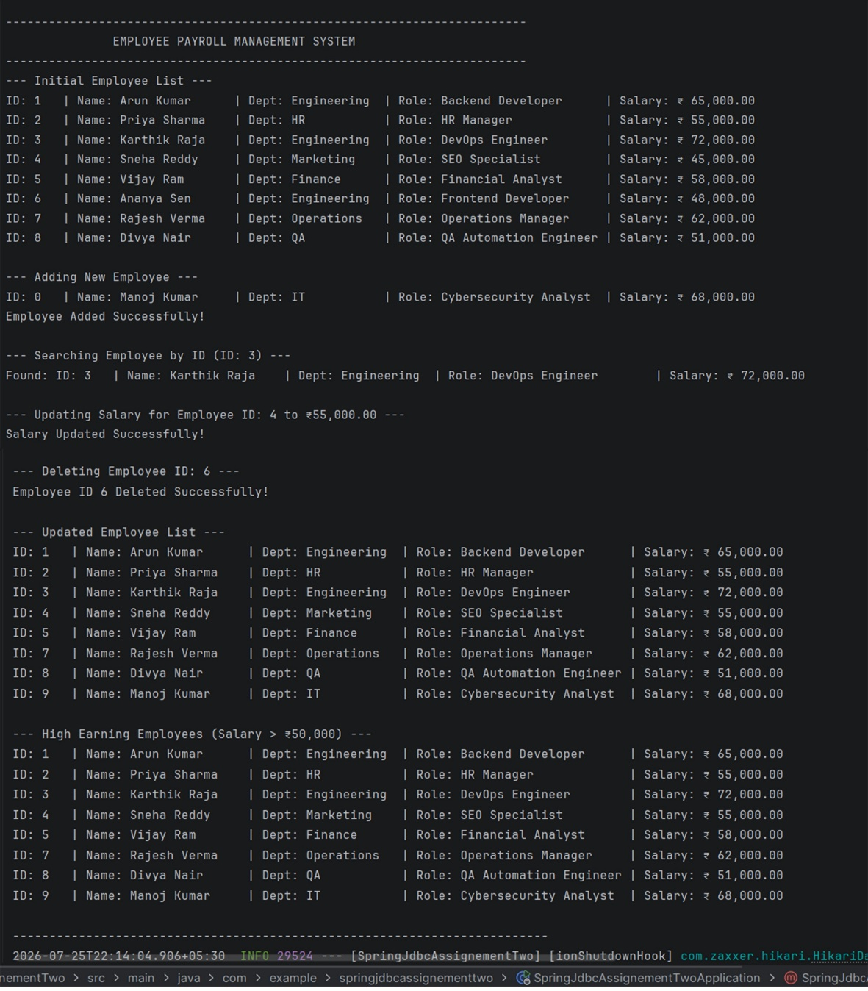

Database Table:
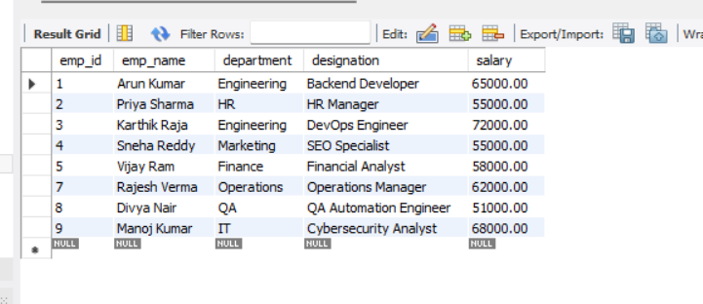
JdbcTemplate
- Spring’s central class for database access (org.springframework.jdbc.core.JdbcTemplate).
- Use: Handles repetitive JDBC boilerplate (opening connections, executing statements, handling SQL exceptions, closing resources).
  - jdbcTemplate.query() — Fetches records using SELECT statements.
  - jdbcTemplate.update() — Executes INSERT, UPDATE, and DELETE queries.
RowMapper
- A Spring JDBC interface (RowMapper<T>) that maps database rows to Java objects. (T stands model name like a Employee, Student etc)
- Use : Converts raw SQL tabular data (ResultSet) into strongly typed Java domain models (Employee).
- EmployeeRowMapper extracts column values (emp_id, emp_name, salary) row-by-row and constructs Employee objects.
Repository Layer (@Repository)
- The Persistence Layer (EmployeeRepository) that interacts directly with MySQL.
- Use: Encapsulates all raw SQL statements away from the main application logic.
- Executes low-level database operations: save(), findAll(), findById(), updateSalary(), and deleteById().
Service Layer (@Service)
- The Business Logic Layer (EmployeeService) sitting between the presentation runner and the repository.
- Use: Enforces business rules and decouples user interactions from raw database queries.
- Receives requests from the application runner, processes logical checks, and invokes repository methods.

Assignment 3: Product Inventory Management System using Spring JDBC and MySQL
Objective
Build a Product Inventory System to manage product details.
Requirements
Database Setup
- Create a MySQL database named inventorydb.
- Create a products table with:
  - product_id (Primary Key)
  - product_name
  - category
  - price
  - quantity
SQL Tasks
- Create the table using schema.sql.
- Insert at least 15 product records using data.sql.
Application Development
- Create:
  - Product.java
  - ProductRepository.java
  - ProductService.java
  - ProductRowMapper.java
- Implement CRUD operations using JdbcTemplate:
  - Add Product
  - View All Products
  - Search Product by ID
  - Update Product Price
  - Delete Product
- Create additional methods:
  - Find Products by Category
  - Display Products with Quantity Less Than 10
  - Calculate Total Inventory Value
Expected Features
- Use custom RowMapper.
- Use parameterized SQL queries.
- Display results in the console.

Solution:
structure
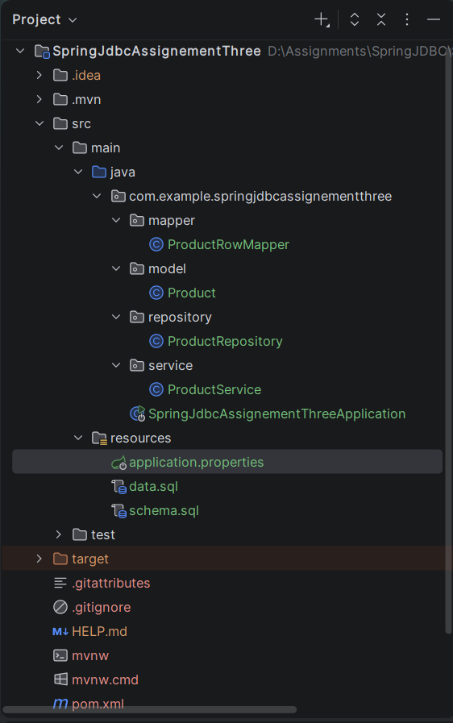

pom.xml
<?xml version="1.0" encoding="UTF-8"?>
<project xmlns="http://maven.apache.org/POM/4.0.0" xmlns:xsi="http://www.w3.org/2001/XMLSchema-instance"
xsi:schemaLocation="http://maven.apache.org/POM/4.0.0 https://maven.apache.org/xsd/maven-4.0.0.xsd">
<modelVersion>4.0.0</modelVersion>
<parent>
<groupId>org.springframework.boot</groupId>
<artifactId>spring-boot-starter-parent</artifactId>
<version>4.1.0</version>
<relativePath/> <!-- lookup parent from repository -->
</parent>
<groupId>com.example</groupId>
<artifactId>SpringJdbcAssignementThree</artifactId>
<version>0.0.1-SNAPSHOT</version>
<name>SpringJdbcAssignementThree</name>
<description>SpringJdbcAssignementThree</description>
<url/>
<licenses>
<license/>
</licenses>
<developers>
<developer/>
</developers>
<scm>
<connection/>
<developerConnection/>
<tag/>
<url/>
</scm>
<properties>
<java.version>21</java.version>
</properties>
<dependencies>
<dependency>
<groupId>org.springframework.boot</groupId>
<artifactId>spring-boot-starter-data-jdbc</artifactId>
</dependency>
<dependency>
<groupId>com.mysql</groupId>
<artifactId>mysql-connector-j</artifactId>
<scope>runtime</scope>
</dependency>
<dependency>
<groupId>org.springframework.boot</groupId>
<artifactId>spring-boot-starter-data-jdbc-test</artifactId>
</dependency>
</dependencies>
<build>
<plugins>
<plugin>
<groupId>org.springframework.boot</groupId>
<artifactId>spring-boot-maven-plugin</artifactId>
</plugin>
</plugins>
</build>
</project>

resources/application.properties
spring.application.name=SpringJdbcAssignementThree
spring.datasource.url=jdbc:mysql://localhost:3306/inventorydb?useSSL=false&serverTimezone=UTC&allowPublicKeyRetrieval=truezone=UTC&allowPublicKeyRetrieval=true
spring.datasource.username=root
spring.datasource.password=root@123
spring.datasource.driver-class-name=com.mysql.cj.jdbc.Driver
spring.sql.init.mode=always
spring.sql.init.schema-locations=classpath:schema.sql
spring.sql.init.data-locations=classpath:data.sql

resources/schema.sql
USE inventorydb;
CREATE TABLE IF NOT EXISTS products (
product_id INT PRIMARY KEY AUTO_INCREMENT,
product_name VARCHAR(100) NOT NULL,
category VARCHAR(50) NOT NULL,
price DECIMAL(10, 2) NOT NULL,
quantity INT NOT NULL);

resources/data.sql
INSERT INTO products (product_name, category, price, quantity) VALUES
('Wireless Mouse', 'Electronics', 799.00, 25),
('Mechanical Keyboard', 'Electronics', 2499.00, 8),
('USB-C Cable', 'Accessories', 299.00, 50),
('Gaming Monitor 24"', 'Electronics', 12500.00, 5),
('Bluetooth Speaker', 'Electronics', 1899.00, 15),
('Ergonomic Chair', 'Furniture', 8500.00, 4),
('Standing Desk', 'Furniture', 14990.00, 12),
('Notebook A5', 'Stationery', 120.00, 100),
('Gel Pens (Pack of 10)', 'Stationery', 150.00, 6),
('Desk Lamp', 'Home', 999.00, 18),
('External SSD 1TB', 'Electronics', 6499.00, 7),
('Backpack', 'Accessories', 1299.00, 20),
('Water Bottle 1L', 'Home', 450.00, 9),
('Webcam 1080p', 'Electronics', 3200.00, 11),
('Wireless Charger', 'Accessories', 899.00, 3);

mapper/ProductRowMapper.java
package com.example.springjdbcassignementthree.mapper;
import com.example.springjdbcassignementthree.model.Product;
import org.springframework.jdbc.core.RowMapper;
import java.sql.ResultSet;
import java.sql.SQLException;
public class ProductRowMapper implements RowMapper<Product> {
@Override
public Product mapRow(ResultSet rs, int rowNum) throws SQLException {
Product product = new Product();
product.setProductId(rs.getInt("product_id"));
product.setProductName(rs.getString("product_name"));
product.setCategory(rs.getString("category"));
product.setPrice(rs.getDouble("price"));
product.setQuantity(rs.getInt("quantity"));
return product;
}
}

model/Product.java
package com.example.springjdbcassignementthree.model;
public class Product {
private int productId;
private String productName;
private String category;
private double price;
private int quantity;
public Product() {}
public Product(int productId, String productName, String category, double price, int quantity) {
this.productId = productId;
this.productName = productName;
this.category = category;
this.price = price;
this.quantity = quantity;
}
public Product(String productName, String category, double price, int quantity) {
this.productName = productName;
this.category = category;
this.price = price;
this.quantity = quantity;
}
public int getProductId() { return productId; }
public void setProductId(int productId) { this.productId = productId; }
public String getProductName() { return productName; }
public void setProductName(String productName) { this.productName = productName; }
public String getCategory() { return category; }
public void setCategory(String category) { this.category = category; }
public double getPrice() { return price; }
public void setPrice(double price) { this.price = price; }
public int getQuantity() { return quantity; }
public void setQuantity(int quantity) { this.quantity = quantity; }
@Override
public String toString() {
return String.format("ID: %-3d | Name: %-22s | Category: %-12s | Price: ₹%,9.2f | Qty: %-3d",
productId, productName, category, price, quantity);
}
}

service/ProductService.java
package com.example.springjdbcassignementthree.service;
import com.example.springjdbcassignementthree.model.Product;
import com.example.springjdbcassignementthree.repository.ProductRepository;
import org.springframework.stereotype.Service;
import java.util.List;
import java.util.Optional;
@Service
public class ProductService {
private final ProductRepository repository;
public ProductService(ProductRepository repository) {
this.repository = repository;
}
public void addProduct(Product product) {
repository.save(product);
}
public List<Product> getAllProducts() {
return repository.findAll();
}
public Optional<Product> getProductById(int productId) {
return repository.findById(productId);
}
public boolean updateProductPrice(int productId, double newPrice) {
return repository.updatePrice(productId, newPrice) > 0;
}
public boolean deleteProduct(int productId) {
return repository.deleteById(productId) > 0;
}
public List<Product> getProductsByCategory(String category) {
return repository.findByCategory(category);
}
public List<Product> getLowStockProducts(int threshold) {
return repository.findByQuantityLessThan(threshold);
}
public double getTotalInventoryValue() {
return repository.calculateTotalInventoryValue();
}
}

repository/ProductRepository.java
package com.example.springjdbcassignementthree.repository;
import com.example.springjdbcassignementthree.mapper.ProductRowMapper;
import com.example.springjdbcassignementthree.model.Product;
import org.springframework.jdbc.core.JdbcTemplate;
import org.springframework.stereotype.Repository;
import java.util.List;
import java.util.Optional;
@Repository
public class ProductRepository {
private final JdbcTemplate jdbcTemplate;
public ProductRepository(JdbcTemplate jdbcTemplate) {
this.jdbcTemplate = jdbcTemplate;
}
// Add Product (Parameterized Query)
public int save(Product product) {
String sql = "INSERT INTO products (product_name, category, price, quantity) VALUES (?, ?, ?, ?)";
return jdbcTemplate.update(sql, product.getProductName(), product.getCategory(), product.getPrice(), product.getQuantity());
}
// View All Products
public List<Product> findAll() {
String sql = "SELECT * FROM products";
return jdbcTemplate.query(sql, new ProductRowMapper());
}
// Search Product by ID (Parameterized Query)
public Optional<Product> findById(int productId) {
String sql = "SELECT * FROM products WHERE product_id = ?";
List<Product> list = jdbcTemplate.query(sql, new ProductRowMapper(), productId);
return list.stream().findFirst();
}
// Update Product Price (Parameterized Query)
public int updatePrice(int productId, double newPrice) {
String sql = "UPDATE products SET price = ? WHERE product_id = ?";
return jdbcTemplate.update(sql, newPrice, productId);
}
// Delete Product (Parameterized Query)
public int deleteById(int productId) {
String sql = "DELETE FROM products WHERE product_id = ?";
return jdbcTemplate.update(sql, productId);
}
// Find Products by Category (Parameterized Query)
public List<Product> findByCategory(String category) {
String sql = "SELECT * FROM products WHERE category = ?";
return jdbcTemplate.query(sql, new ProductRowMapper(), category);
}
// Display Products with Quantity Less Than Threshold (Low Stock)
public List<Product> findByQuantityLessThan(int threshold) {
String sql = "SELECT * FROM products WHERE quantity < ?";
return jdbcTemplate.query(sql, new ProductRowMapper(), threshold);
}
// Calculate Total Inventory Value (SUM of price * quantity)
public Double calculateTotalInventoryValue() {
String sql = "SELECT SUM(price * quantity) FROM products";
Double total = jdbcTemplate.queryForObject(sql, Double.class);
return total != null ? total : 0.0;
}
}

SpringJdbcAssignementThreeApplication.java
package com.example.springjdbcassignementthree;
import com.example.springjdbcassignementthree.model.Product;
import com.example.springjdbcassignementthree.service.ProductService;
import org.springframework.boot.CommandLineRunner;
import org.springframework.boot.SpringApplication;
import org.springframework.boot.autoconfigure.SpringBootApplication;
import java.util.List;
@SpringBootApplication
public class SpringJdbcAssignementThreeApplication implements CommandLineRunner {
private final ProductService service;
public SpringJdbcAssignementThreeApplication(ProductService service) {
this.service = service;
}
public static void main(String[] args) {
SpringApplication.run(SpringJdbcAssignementThreeApplication.class, args);
}
@Override
public void run(String... args) {
System.out.println("\n-----------------------------------------------------------------------------------------");
System.out.println(" PRODUCT INVENTORY MANAGEMENT SYSTEM (SPRING JDBC) ");
System.out.println("-----------------------------------------------------------------------------------------\n");
// View All Products
System.out.println("--- All Inventory Products (Initial 15 Records) ---");
displayProducts(service.getAllProducts());
// Add New Product -> Display ONLY the newly added record
System.out.println("\n--- Adding New Product ---");
Product newProduct = new Product("Noise Cancelling Headset", "Electronics", 4999.00, 14);
service.addProduct(newProduct);
System.out.println("Product Added Successfully!");
List<Product> allProducts = service.getAllProducts();
if (!allProducts.isEmpty()) {
Product added = allProducts.get(allProducts.size() - 1);
System.out.println("Added Record: " + added);
}
// Search Product by ID
System.out.println("\n--- Searching Product by ID (ID: 4) ---");
service.getProductById(4).ifPresentOrElse(
prod -> System.out.println("Found: " + prod),
() -> System.out.println("Product not found.")
);
// Update Product Price -> Display ONLY the updated record
System.out.println("\n--- Updating Price for Product ID: 2 to ₹2,199.00 ---");
if (service.updateProductPrice(2, 2199.00)) {
System.out.println("Price Updated Successfully!");
service.getProductById(2).ifPresent(prod -> System.out.println("Updated Record: " + prod));
}
// Delete Product
System.out.println("\n--- Deleting Product ID: 9 ---");
if (service.deleteProduct(9)) {
System.out.println("Product ID 9 Deleted Successfully from Database.");
}
// Search Products by Category
System.out.println("\n--- Products in Category: 'Electronics' ---");
displayProducts(service.getProductsByCategory("Electronics"));
// Display Low Stock Products (Quantity < 10)
System.out.println("\n--- Low Stock Alert (Quantity < 10) ---");
displayProducts(service.getLowStockProducts(10));
// Total Inventory Value Calculation
System.out.println("\n--- Overall Inventory Financials ---");
double totalVal = service.getTotalInventoryValue();
System.out.printf("Total Total Valuation of Stock in Hand: ₹%,.2f\n", totalVal);
System.out.println("\n-----------------------------------------------------------------------------------------");
}
private void displayProducts(List<Product> products) {
if (products.isEmpty()) {
System.out.println("No records found.");
} else {
for (Product p : products) {
System.out.println(p);
}
}
}
}
Output:
Console output
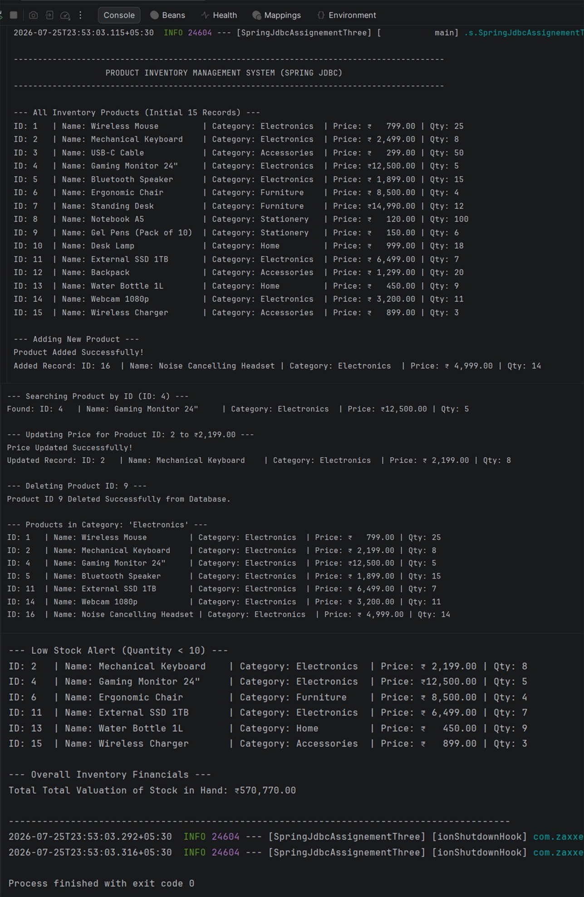
Database output:
